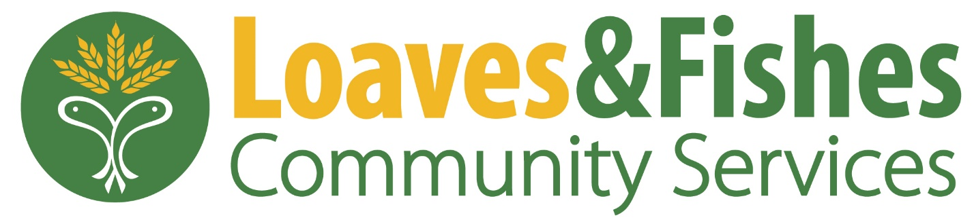
Community Health Internship
The Community Health intern will work closely with our Director of Community Health to provide support in our Nutrition programs. You will gain experience in providing nutrition education to clients, building healthy food options, as well as the opportunity for interacting in the community. At Loaves & fishes, we believe that food is a right and not a privilege. It is our goal to offer items from each of the five good groups and encourage clients to make healthy lifestyle choices. We do not a have a Registered Dietitian on Staff.
When
Spring Internship
Summer Internship
Fall Internship
Where
Loaves & Fishes Community Services - 1871 High Grove Lane, Naperville, IL 60540
Qualifications
Candidates must possess a passion for supporting non-profit work and serving those in need. Intern should have a strong communication, writing and computer skills. Undergraduate and graduate students are encouraged to apply. This position does involved participation of operational needs, so the ability to stand and/or move around for a minimum of 3 hours is necessary.
Commitment
10-15 hours a week for at least one semester. This is an unpaid position.
Training
All interns will be trained and supervised by the Director of Community Health

Majors
The following majors are encouraged to apply: Nutrition, Public Health
To apply for this internship, please submit a resume and cover letter to volunteer@loaves-fishes.org

